

An education program for preschool age children offered in partnership with:

Seward Public Schools

**Seward**

**Elementary**

**Preschool**

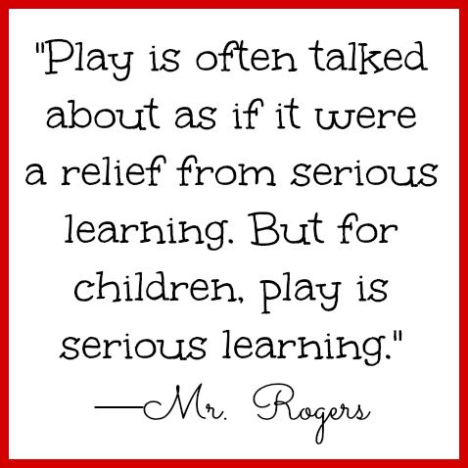

We are excited to have you and your child be part of our program! This handbook is designed to answer some of your questions and give you an overview of the policies and procedures of our program. Feel free to contact your teacher any time with questions or concerns you may have. We look forward to watching your child soar this year!

# Welcome to Seward Elementary Preschool

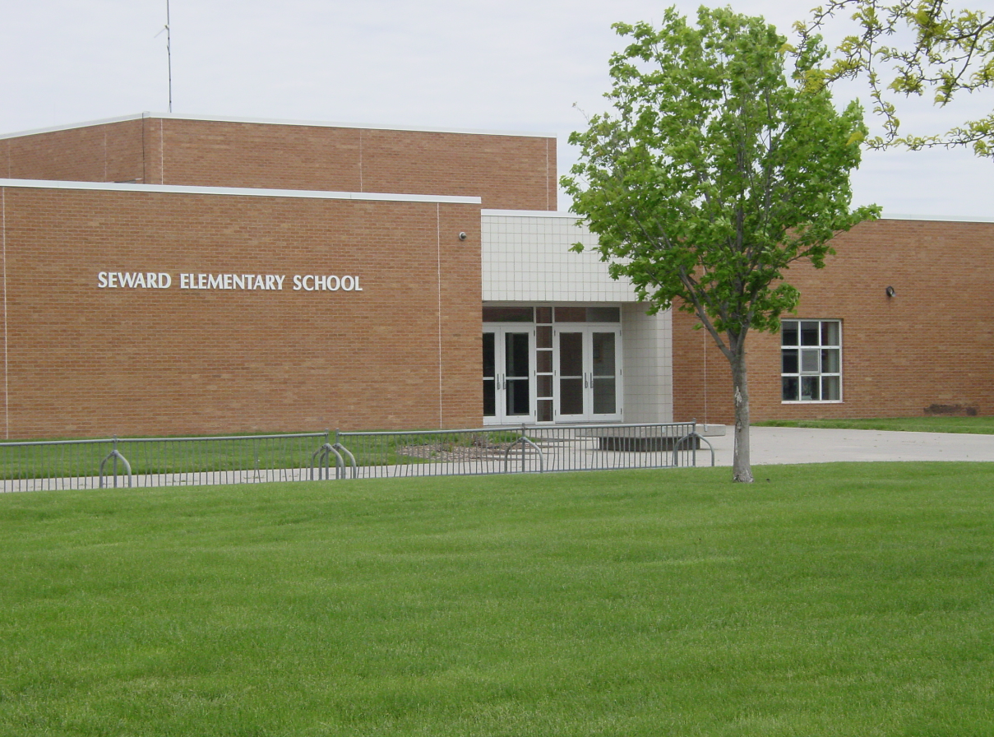

Preschool classes are offered Tuesday through Friday.

NO school on Mondays.

AM class time: 8:00am-11:30am

PM class time: 11:30am-3:00pm

State funded early childhood education programs must adhere to age eligibility guidelines set by the State as stated in Rule 11. Children who are eligible to enroll in kindergarten (those who reach 5 by July 31st of the current year), may not participate in a State funded preschool program.

The Seward Public Schools Mission Statement:

EVERY STUDENT EVERY DAY A SUCCESS

**PURPOSE**

Seward Early Childhood Education Preschool offers a variety of learning experiences. These experiences develop skills and promote growth physically, socially, emotionally, and mentally, at individual levels.

**PHILOSOPHY**

Seward Early Childhood Education believes:

* Every individual has fundamental worth and unique importance
* Every person, no matter how young or how old, has potential to contribute to the lives of others
* Play is work for young children and they learn best through direct experience

**CURRICULUM/ASSESSMENT**

Creative Curriculum is a thematic language-based approach to learning, integrating language arts, science, math, social skills, and motor skills. Focusing on objectives that are most predictive of school success and that are linked to State and Early Learning Standards.

TEACHING STRATEGIES - GOLD, Objectives for Development and Learning, Birth through Kindergarten, an innovative assessment system will be used for assessing all children in the Seward Preschool Program. The objectives represented address all areas of development (social-emotional, physical, language, and cognitive) as well as content learning in literacy, mathematics, science and technology, social studies, and the arts.

**ARRIVAL/DEPARTURE**

AM session’s arrival: Please bring your child through the main entrance and wait with your child on the bench located right inside the main doors of the building. Your child’s teacher will meet you there at 8:00am. Please remain with your child until the teacher has arrived.

AM session’s departure/PM session’s arrival: Please meet by the gym doors to the west of the building. You may park in the bus lane but please park towards the back or pull way up so there is room for the bus to park and drop off kids.

PM session’s departure: Please meet inside the main doors and pick your child up from the bench located right inside the main doors of the building.

**DAILY SCHEDULE**

Each classroom has its own schedule that best fits their needs. Your child’s daily routine will be given to you at the beginning of the school year.

Below is an example:

**MORNING AFTERNOON**

8:00 Arrival/Breakfast/Free play 11:30 Greeting

8:40 Opening circle time 11:35 Attendance/R.R./Free play

9:00 Learning Centers 11:50 Lunch

10:10 Clean up/Show & Tell 12:20 Recess

10:20 Story Time 12:50 Music/Movement/Unit

10:30 Snack/Sm Groups/Library (Wed) 1:10 Sm Group/Library 1:15(T)

11:00 Recess 1:30 Learning Centers

11:25 Good Bye 2:30 Circle Time/Calendar/Weather

11:30 Dismiss 3:00 Dismiss

**BIRTH CERTIFICATES AND IMMUNIZATIONS**

The law requires that all children attending preschool provide the school with an official birth certificate and current immunization record. Please have both of these to your child’s teacher by the end of September.

**ABSENCES**

If a child is not present in school he is counted absent. Parents should call the school when your child is going to be absent. This is helpful to the teacher when beginning activities. Children who must remain indoors because of health reasons must bring a note to that effect. These notes must be sent to the teacher on a daily basis.

**SCHOOL CLOSING**

In the event of inclement weather, information pertaining to the closing of the Seward Public Schools will be broadcast on the following stations:

Omaha Radio Lincoln Radio Lincoln TV

KFAB 1100 KZKX 96FM Channel 10/11

Remind and Facebook notifications will also communicate weather closings.

In the event of a late start, only the AM session of Preschool will be cancelled for that day.

**ILLNESS**

We want to keep the children as healthy as possible. In order to do this, we need your cooperation. Your child should not be brought to preschool if he/she has a fever of 100 degrees or more, vomiting, diarrhea, undiagnosed rash, eye or ear inflammation or discharge, or a communicable disease. NO medication can be given without written instructions from the parent, and medication must be in the original bottle. If your child should become ill at preschool, parents will be called, and the child will be separated from the other children until parents arrive.

Children need to be symptom free for 24 hours, without the use of fever reducing medication, before returning to school.

Children receiving antibiotics, and antifungal, or other medication for infection need to be on the medication for 24 hours before returning to school.

Children who exhibit signs/symptoms of contagious conditions should have a doctor’s note before returning.

The 24 hour rule applies to: children who are ill and stay home

children who are sent home ill

**24 HOUR RULE**



**COMMUNICATION**

Preschool newsletters are developed and sent home to keep parents informed of preschool events and activities. An outline of our units of study, cooking experiences, and activities is provided and weekly planning sheets will also be sent home at the beginning of each week. Also included are current finger plays and songs that your child will be learning. Twice yearly, (typically in October and March), parent teacher conferences will be held to discuss your concerns and share your child’s progress results from the Teaching Strategies GOLD assessment. Home Visits can be scheduled at this time. Please visit with your child after school and check their book bags for notes, papers, and projects. Your child’s teacher will also have a Remind communication account set up so please register your phone or email through that.

**BREAKFAST/LUNCH**

A breakfast will be offered to preschoolers for a cost of $1.60.

A lunch will be offered to preschoolers for a cost of $2.50.

Please schedule an account at the beginning of the year. If you have multiple children at the school, individual checks need to be written to pay for each of their accounts.

**SNACK BREAK**

The preschoolers will have a snack break each day. Preschoolers are encouraged to bring snacks at the beginning of the school year and whenever the cupboards get low and snacks are needed.

**BIRTHDAYS**

If a child brings treats for the room on his/her birthday, these treats will be passed out during snack time. Please notify your child’s teacher ahead of time on what you plan to bring.

**SCHOOL DRESS CODE**

Schools are expected to provide for students a good learning environment. Student dress and grooming play an important part in creating an appropriate atmosphere. The school strongly encourages the student and his/her parents to come to a decision about the proper dress for school. Parents are responsible for providing a change of clothing and diapers/pull-ups/wipes when applicable. For playing outdoors in wet or snowy weather, your child needs to have snow boots marked well with names, as well as coats, mittens, and hats!

**EMERGENCY DRILLS**

Regular emergency fire, tornado, and intruder drills are conducted throughout the year. All students, staff and visitors are expected to take part in the drills.

**PERSONAL POSSESSIONS**

Please do not allow your child to bring personal items (i.e. toys, candy) to school unless requested by the classroom staff.

NO PLAY GUNS or WEAPONS are allowed at preschool.

**INITIAL HOME VISIT**

Your child’s teacher will be contacting you and setting up an initial home visit prior to school starting. The purpose of the home visit is to build the relationship between home and school. These visits will allow for you to ask questions and discuss any concerns you may have. It will also be a great way for you and your child to get familiar with and meet the teacher before the first day of school.

**IMPORTANT PHONE NUMBERS**

Marty Telecky is in charge of transportation. Transportation is an option for the preschool students but needs to be set up ahead of time. Transportation also needs to be notified if your child is not going to be in school or if your child’s drop off/pick up location changes.

Marty/Bus: 402-643-2941

Seward Elementary School: 402-643-2968

The office at Seward elementary is staffed from 7:45am-4:00pm Monday through Friday. Please call the office if your child is going to be absent. A voicemail can also be left. It is important that each child is accounted for each day.

**TUITION GUIDELINES**

Seward Public Schools Preschool will offer enrollment to children according to the following tuition guidelines (sliding fee scale):

Tuition Per Session

Special Education (IFSP/IEP) -No Cost

Free Meal Eligibility- No Cost except transportation costs if applicable

Reduced Meal Eligibility- $1.50 per session plus transportation costs if applicable

Full Pay Meal Eligibility- $3.00 per session plus transportation costs if applicable

Parents/guardians will be expected to pay quarterly. If payment is not received after two weeks of billing you will receive a late notice. Seward Public Schools may dismiss students from the program if payment is not received within a reasonable period of time.

**Preschool Staff**

Early Childhood Special Education Teacher

Heidi Weber

Office Phone 402-643-2968

[heidi.weber@sewardschools.org](mailto:heidi.weber@sewardschools.org)

Early Childhood Special Education Teacher

Jen Frihauf

Office Phone 402-643-2968

Jen.frihauf@sewardschools.org

Speech Therapist

Nicole Chiles

Physical Therapist

Jan Meehl

Occupational Therapist

Sue Bainter

