Nov. Staff Development Newsletter

DR. MATT DOMINY

THANKFUL
Thank you!

They are two words that have the power to transform our health, happiness, athletic performance and success. Research shows that grateful people are happier and more likely to maintain good friendships. A state of gratitude, according to research by the Institute of HeartMath, also improves the heart's rhythmic functioning, which helps us to reduce stress, think more clearly under pressure and heal physically. It's actually physiologically impossible to be stressed and thankful at the same time. When you are grateful you flood your body and brain with emotions and endorphins that uplift and energize you rather than the stress hormones that drain you.

Gratitude and appreciation are also essential for a healthy work environment. In fact, the number one reason why people leave their jobs is because they don't feel appreciated. A simple thank you and a show of appreciation can make all the difference.-Jon Gordon

November is a great month to pause and think about all the wonderful people, things, beliefs and ideas that impact our lives. I hope that you will join me this month in truly being thankful for all that has been afforded to us. It is a blessing to be able to work together, work with students and families to help shape what the world is to become.
I am thankful for each of you and all that you do for our student, families, and staff.

Element #32 from our instructional model relates to motivating and inspiring our students. I felt like this element connected well to promoting an attitude of thankfulness in our students and staff. Our focus question for Element #32 is, What will I do to motivate and inspire students? Take a minute to reflect on this question and think about all of the things you do to inspire and motivate kids. How do you let students know you are thankful for them, that you are proud of them, that you believe in them?

A few ideas shared in our book, The New Art and Science of Teaching, include cultivating growth mindset, possible selves activities, personal projects, altruism projects, and gratitude journals. (See page 75-76 for more detail)

Some of the ideas shared are about self-actualization, while other activities are more about the connection to something greater than self. We know that when we are successful in this element we will see the following behaviors:
*Students engage with community members in meaningful ways.
*Students work on projects of their own design that are meaningful to them.
*Students describe the class as motivating or inspiring.

I hope your family has a wonderful Thanksgiving. Thank you for all that you do for our students and our community.

Matt Dominy
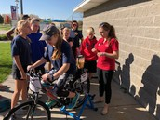 | 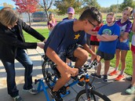 | 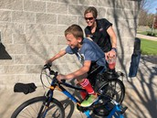
MS WELLNESS DAY- SMOOTHIE BIKES! | MS WELLNESS DAY- SMOOTHIE BIKES! | MS WELLNESS DAY- SMOOTHIE BIKES!

